Virtual Christmas Fair

To help with fundraising for St Peter’s, why not order some treats from the selection below?
All are handmade. Order early: supplies are limited!

Christmas Food
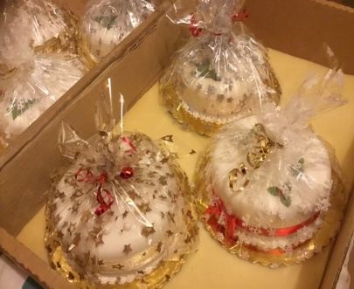
6-inch, iced Christmas cake £ 11.00 Quantity
6-inch, uniced Christmas cake £ 9.00 Quantity
7-inch, iced Christmas cake £ 14.00 Quantity
7-inch, uniced Christmas cake £ 12.00 Quantity
2lb Christmas pudding £ 10.00 Quantity
6 mince pies £ 1.75 Quantity
12 mini mince pies £ 3.00 Quantity
All-butter shortbread rounds £ 4.00 Quantity

Mixed-Colour Knitwear
Hat £ 5.00 Adult’s Quantity Child’s Quantity
Gloves £ 5.00 Ladies’ Quantity Men’s Quantity
Fingerless gloves £ 5.00 Ladies’ Quantity Men’s Quantity
Socks £ 15.00 Adult’s Quantity Child’s Quantity

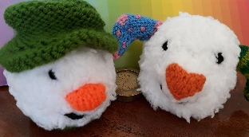
Novelty Knitted Items with a Hidden Chocolate Orange
Snowman £ 4.00 Quantity
Dog £ 4.00 Quantity

Your name Enter your name here
Your address Enter your address here
Your phone number Enter your phone number here

Order by Sunday 7th November in any of the following ways.
- Print and return your order form to church
- E-mail your completed form to fmseaton41@gmail.com
- Phone your order to: Sally Mundy 01884 254378
Gill Heard 01884 258600
Sheila Scofield 01884 256819
Mary Seaton 01884 252018

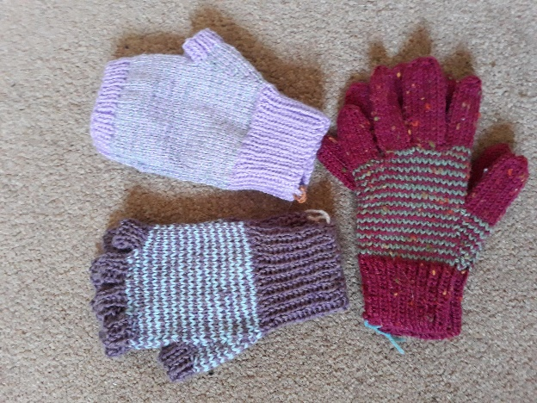
Come for a cuppa and collect your completed order at St Peter’s on Saturday 11th December from 10.00 am to 12.00 noon, or pick up your items at church on Sunday 12th December. Please have the correct money ready (additional donations are welcome).

Many thanks for your order and for your generosity.

